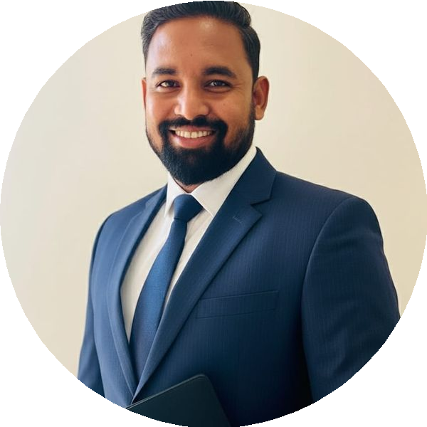
SUMMARY
SUDHIR KUMAR RAUTRAY
Deputy General Manager | Leadership | Strategic Planning | Vendor Management
E 09703898420 @ sudhir.rautray@gmail.com
9 Chennai
I am a customer-oriented General Manager with 18 years of experience focused on increasing revenues and expanding margins. My adaptive and deadline-oriented approach allows me to consistently execute and complete multiple projects in high-stress environments. As a meticulous leader and strategic planner, I leverage my comprehensive managerial acumen to offer vision and motivate teams towards achieving targets
Forecasting & Scheduling

EXPERIENCE

Deputy General Manager - Tele sales & Vendor Management

Bank Bazaar .com
12/2018 – Current Chennai
A financial services company specializing in various financial products
Data Interpretation
- Led Contact Center Operations including In-house G Vendor line of business across PAN India for cards
- Established 300 Seats business externally with 40% reduction in cost
Outsourcing
- Increased month-on-month revenue growth by transitioning in-house business to external and ensuring positive margins
- Managed a portfolio of 400 FTEs for Cards G loans ensuring profitability
- Established effective utilization of telephonic metrics as per COPC standards
- Collaborated with Service Excellence, Quality, LGD teams to improve Processes and TAT
- Drove year-over-year business growth while leading operations, strategic vision, and planning

Operations Manager - Sales

Epicenter Technologies Private Limited
04/2018 - 11/2018 Mumbai
A company focused on technology-based solutions and services
- Led 250 Pre-sales tele calling associates to generate quality walk-ins across various projects
- Performed outbound sales activities such as cold calling, lead follow-up, and sales qualifications
- Converted prospects into customers by showcasing appropriate residential properties
- Identified and resolved unauthorized, unsafe, or ineffective practices

SKILLS
Tele sales
Vendor Negotiations
Client Relations
Call Center Operations
Decision Making

Cost Analysis

Process Improvements

EXPERIENCE

Operations Manager - Tele sales

Concentrix Daksh Services India Private Limited
04/2012 - 01/2018 Vishakhapatnam & Hyderabad
A leading global provider of business services
- Managed Contact Center for constant performance achievements of 300 FTEs
- Achieved annually 70 Cr Revenue (Premium) with 7% (NOP) conversion
- Drove cost reduction initiatives in processes with automation opportunities
- Negotiated contracts with clients to obtain best pricing and terms
- Developed systems G procedures to improve operational quality G team efficiency
- Directed initiatives to enhance work environment, company culture, and overall strategy

Senior Executive - Customer Service Delivery

Bharti Airtel Ltd
02/2007 - 01/2011 Bhubaneswar
A leading telecommunication company
- Reduced attrition rate by 15% through effective churn analysis and monitoring practices.
- Achieved targets (numbers G revenue) as per AOP.
- Analyzed zero-user prediction to control high ARPU churn.
- Maintained positive customer relations by addressing problems and implementing corrective actions.

EDUCATION

MBA

Mahatma Gandhi University
02/2010 - 03/2012 Meghalaya

BBA

Guru Ghasidas University
02/2004 - 02/2007 Chhattisgarh

Higher Secondary

Kendriya Vidyalaya Ballygunge
04/2003 - 03/2004 Kolkata

